# Lab 5 – Exploring the Main Commands of MATLAB (I)

## Lab Warm Up Assessment:

**Evaluate the following MATLAB expressions. Where x, y, z has values equal to 2.5, 0.5 and 2 respectively.**

1. **x + y + z**
2. **x * y * z**
3. **x / z**
4. **x ^ y**
5. **x ^ z**

**Code:**

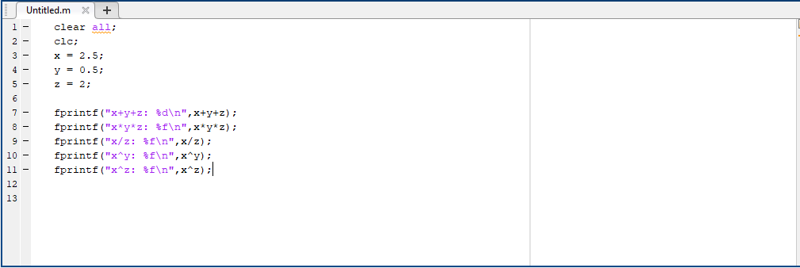

**Output:**

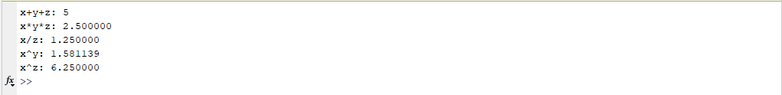

**Given two sides a = 3.2 and b = 4.6 of a triangle and angle theta = 60 between these two sides, find the length of the third side and the arc of the triangle.**

**Code:**

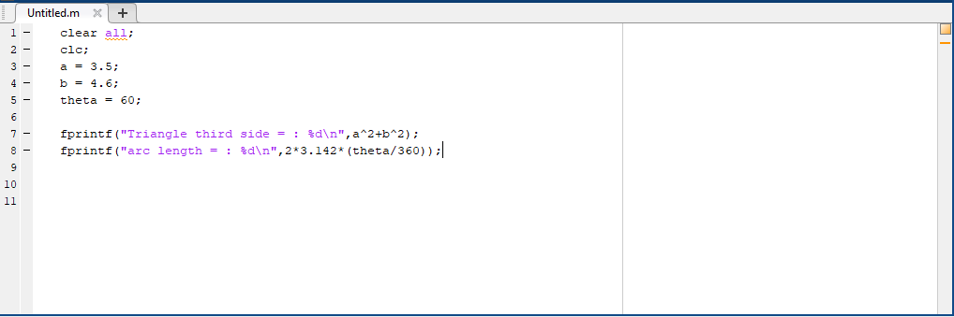

**Output:**



**Write a program to convert temperature given in degrees Centigrade, say 35.4 C, to degrees Fahrenheit**.

**Code:**

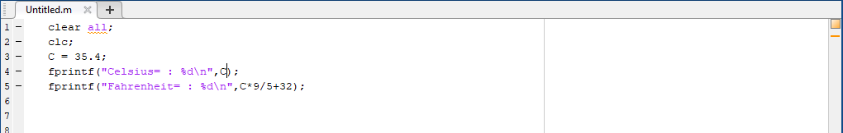

**Output:**

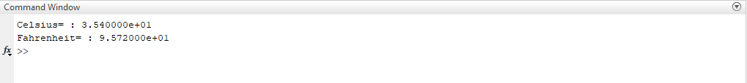

## Exercise

**Evaluate the following MATLAB expressions. Where i, j, k and l have the following values:**

1. **i*j + k*l**
2. **I * (j+k) * l**
3. **(i*j) + (k/l)**
4. **(i+j) * i^j**

**Code:**

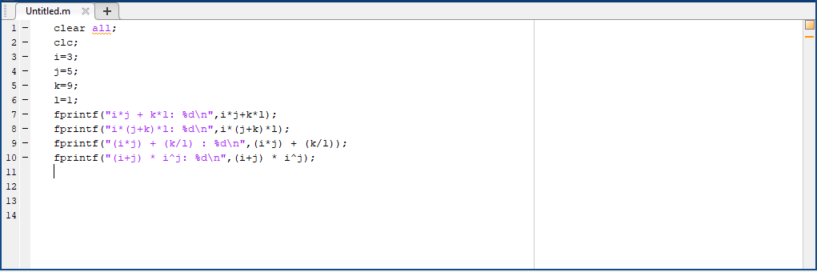

**Output:**

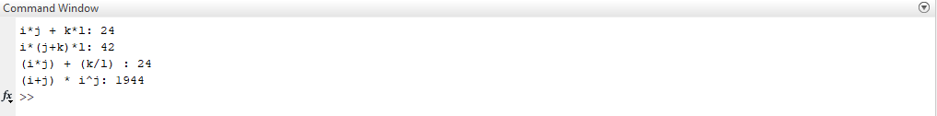

**Evaluate the following MATLAB expressions. Where x = 3-4i and y=1+2i.**

1. **X + y**
2. **X – y**
3. **X * z**
4. **x/y**
5. **X power y**

**Code:**

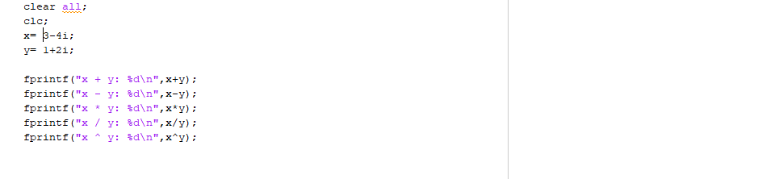

**Output:**

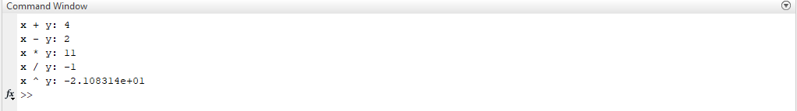

**Write a program to solve Quadratic Equation in MATLAB.**

**Code:**

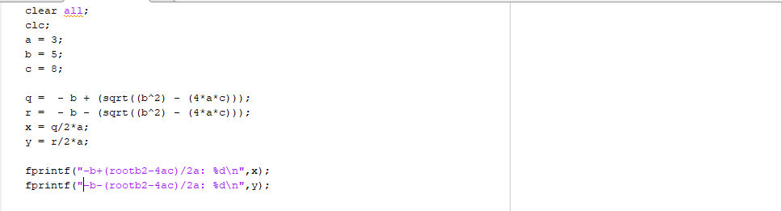

**Output:**

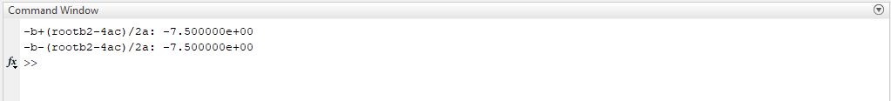

**Write a program to solve Distance formula in MATLAB.**

**Code:**

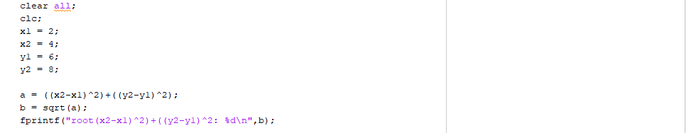

**Output:**



**Write a program to solve mid-point in MATLAB.**

**Code:**

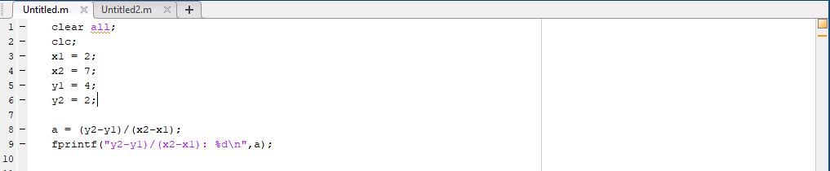

**Output:**

